**Impact of Firm Characteristics on Management Quality in Sweden: An Econometric Analysis**

**JEL classification: L10, M11, M14, M19**

**Hannah Saethereng, Westminster University**

**12/14/2023**

1. **Introduction**

The performance of a business is often closely tied to the quality of its management. In this study, we aim to investigate the factors influencing management quality within firms. Specifically, we explore the impact of various firm characteristics on management scores. Understanding these dynamics is crucial for strategic decision-making and organizational effectiveness.

The question we seek to answer is: What factors contribute to variations in management quality across firms? This question holds significance as high-quality management is linked to improved performance and employee retention. We approach this inquiry through an econometric analysis, utilizing a comprehensive dataset and regression techniques.

Theories and mechanisms explored in this report are The Human Capital Theory: Variables like "degree_m," "degree_nm," and "degree_t" can be linked to the Human Capital Theory, suggesting that the educational composition of the workforce may impact the overall quality of management. Leadership Theories: "i_seniority" may be related to leadership theories, indicating that the seniority of managers within a company could influence management quality. The Organizational Culture Theory: Variables such as "reliability" might be connected to organizational culture theory, as reliability measures could be indicative of certain cultural aspects within the organization. The mechanisms of Variables like "competition" and "export" might reflect external pressures and market dynamics, influencing strategic decisions made by management.

This paper contributes to the existing body of research by providing empirical evidence on the determinants of management quality, filling a gap in the current literature. Our findings offer actionable insights for businesses aiming to enhance their management practices by identifying key drivers.

Several notable studies have delved into the impact of firm characteristics on management quality, shedding light on the intricate relationships between various organizational factors and the effectiveness of management practices. For instance, the study conducted by Jimenez and Pagano (2011) investigates the factors influencing management quality, with a specific focus on state infrastructure management. Their findings reveal that infrastructure management grades are affected by various political, fiscal, and organizational factors. Contrary to some hypotheses, a divided legislature is associated with higher government performance project (GPP) grades. Additionally, legislative term limits are found to be significantly correlated with higher GPP grades. Urbanization also has a positive but relatively marginal impact on infrastructure management quality. (Jimenez, B. S., & Pagano, M. A. (2011)) This study contributes valuable insights into the nuanced dynamics of management quality within the public sector, offering a unique perspective that enriches the existing literature.

1. **Data**

The primary source of data for this study is the World Management Survey (WMS). Specifically, the dataset used is the WMS dataset for Bekes-Kezdi (2021). This dataset encompasses information on manufacturing companies from 24 countries, and the data collection period spans from 2004 to 2015.

To measure the quality of management, they have taken the average of all the different management scores, including questions about operations, monitoring, people, and target.

Other variables we will use in our regression are the number of firm employees declared in the interview and the firm's age (Firmage). Manager's seniority in the company(i_seniority). Percentage of production exported (Export). Percentage of managers with a college degree(degree_m). Percentage of non-managers with a college degree(degree_nm). Percentage of all workforce with a college degree (degree_t). Binary variable indicating whether the company is multinational(i_multinational). Binary variable indicating whether the company faces high competition(compet_dummy). Reliability measure, calculated as the sum of i_knowledge and i_willingness scores (reliability).

We looked into the distribution of management quality, and it looks normally symmetric. The mean of the management scores is 3.18, and there are 404 observations in the data.

To investigate how competition affects management scores, we made a binary variable indicating whether the company faces high competition. Where 0 means that the company has less than ten competitors and 1 means that it faces high competition with more than ten competitors. We had 205 observations without high competition and 199 observations with high competition, so there was a good number of observations in both cases. As you can see in the two tables below, the median of management score stays consistent through the different ways of observing competition. Note that the box with 0 competitors only had two observations, and that is why it looks very different from the others.

We are also looking at what effect ownership type has on management. As you can see in the box plot below, there is a variation in ownership quality based on the ownership type. “Government” and “Dispersed Shareholder” ownership types seem to have the highest ownership quality, while “Founder-owned, founder CEO” seems to have the lowest mean management quality. From the table below, you can see that most companies have Dispersed shareholder-type Ownership.

Another thing we are looking into is the size of the firm's impact on management quality. We did this by looking at the number of employees. From the plot below, you can see that larger companies are associated with a higher mean management quality score. This matches the observation that Dispersed Shareholders have a better management quality than many other companies because companies with this ownership type are often larger and more mature than smaller companies.

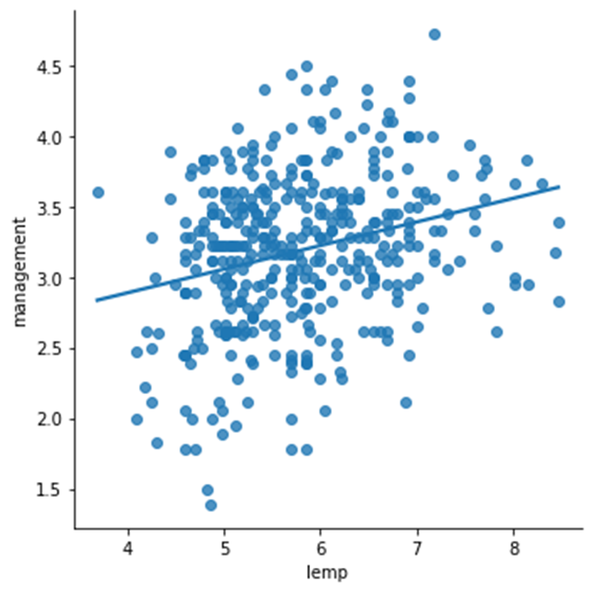

The Econometric model I’m using is:

$$management=β0​+β1​×log(emp_firm)+β2​×firmage+β3​×ownership+β4​×mne_yn+β5​×export+β6​×degree_m+β7​×degree_nm+β8​×degree_t+β9​×i_seniority+β10​×reliability+β11​×compet_dummy+ϵ$$

The estimation method used is Ordinary Least Squares (OLS). OLS minimizes the sum of squared differences between the observed values of the dependent variable and the values predicted by the model.

The regression model employed in this study is subject to certain limitations and assumptions. Firstly, the assumption of homoskedasticity posits a constant variance of residuals, yet the presence of heteroskedasticity could potentially violate this assumption. Secondly, the model assumes the independence of errors, and the emergence of serial correlation poses a potential challenge to this assumption. Furthermore, the model relies on the assumption of linearity, presupposing a linear relationship between the independent and dependent variables. Lastly, the normality of residuals is assumed, and deviations from this normal distribution may impact the reliability of the model. Acknowledging these limitations and assumptions is crucial for a nuanced interpretation of the regression results and underscores the need for careful consideration of potential biases or inaccuracies introduced by these assumptions.

1. **Empirical Results**

When we ran the regression, there were only three significant variables. The ownership types are “Founder Owned, External CEO,” “Other,” and “Reliability measure.” The “Founder Owned, External CEO” variable had a t-value of 0.005, which is statistically significant, but the coefficient is very small, so it is not practically significant; it also only had eight observations of this ownership type, so that could explain the results. “Other” Ownership types is also statistically significant it has a larger effect on the management score. With a coefficient of -0.4191. The reliability measure has a positive impact on management quality, which I expected because I think better organizational culture is tied to the quality of management.

An other thing to notice in the regression is that most ownership types are negative when compared to “Dispersed Shareholders”. Why that is could be because Dispersed Shareholders, as compared to other ownership types, might benefit from a diverse and widespread base of shareholders. This broad ownership structure could potentially contribute to a more balanced decision-making process, minimizing the risk of individual interests dominating managerial decisions. Additionally, the larger size and maturity often associated with Dispersed Shareholders might provide a stable foundation for effective management practices.

The only two ownership types appearing to rival or surpass Dispersed Shareholders in the analysis are "Family owned, external CEO" and "Government." The limited number of observations for "Family owned, external CEO" warrants caution in drawing definitive conclusions. However, the positive association with management quality suggests that a family-owned structure with external CEO leadership may bring a unique blend of familial values and external expertise, positively impacting management practices.

The notable positive impact of "Government" ownership on management quality, based on a substantial number of observations, prompts further exploration. It may indicate that government-owned firms in Sweden are adept at managing their employees, possibly due to rigorous oversight, adherence to regulatory standards, or a focus on long-term stability rather than short-term gains.

The overall negative coefficients for many ownership types compared to Dispersed Shareholders underscore the importance of organizational structure in influencing management quality.

An R-squared of 0.276 means that the model captures about 27.6% of the total variation in management scores, leaving the remaining 72.4% unexplained. This indicates a moderate fit, suggesting that the included variables collectively contribute to explaining a significant portion of the variation in management scores. The relatively lower Adjusted R-squared of 0.142 suggests that the model may not be as effective when considering the trade-off between model complexity and explanatory power. It could indicate that some of the independent variables added to the model might not be contributing meaningfully to the explanation of management scores.

**R-squared: 0.276**

**Adj. R-squared: 0.142**

**=======================================================================================================**

**coef std err t P>|t| [0.025 0.975]**

**-------------------------------------------------------------------------------------------------------**

**Intercept 1.3457 0.520 2.589 0.011 0.313 2.378**

**Family owned, external CEO 0.1567 0.349 0.449 0.654 -0.536 0.850**

**Family owned, family CEO -0.2675 0.203 -1.320 0.190 -0.670 0.135**

**Founder owned, external CEO 4.518e-15 1.58e-15 2.866 0.005 1.39e-15 7.65e-15**

**Founder owned, founder CEO -0.3777 0.364 -1.037 0.302 -1.101 0.346**

**Government 0.1202 0.272 0.442 0.660 -0.420 0.661**

**Other -0.4191 0.173 -2.428 0.017 -0.762 -0.076**

**Private Equity/Venture Capital -0.2207 0.175 -1.262 0.210 -0.568 0.127**

**Private Individuals -0.0683 0.122 -0.561 0.576 -0.310 0.173**

**Log (employment) 0.0787 0.055 1.435 0.155 -0.030 0.188**

**Firm age in years -0.0005 0.001 -0.511 0.610 -0.003 0.002**

**Multinational -0.0163 0.105 -0.156 0.877 -0.225 0.192**

**Exports 0.0002 0.002 0.118 0.906 -0.003 0.003**

**Managers with college degree(%) -0.0027 0.003 -0.790 0.431 -0.010 0.004**

**Non-Managers with college degree(%) -0.0224 0.020 -1.128 0.262 -0.062 0.017**

**All workers with college degree (%) 0.0213 0.022 0.954 0.343 -0.023 0.066**

**Manager's seniority in company -0.0005 0.054 -0.009 0.992 -0.107 0.106**

**Reliability measure 0.1736 0.040 4.351 0.000 0.094 0.253**

**Competition 0.0414 0.099 0.420 0.675 -0.154 0.237**

To support our regression, we tested for heteroscedasticity, and as you can see in the plot, there is no clear evidence of heteroscedasticity. Also, the p-values are high when doing a test, so we fail to reject the null of homoscedasticity in both tests.



We also checked to see if the percentage of management with a college degree had a quadratic relationship. Still, we found that it did not because it became statistically insignificant in my test when I did that. Other variables we could have tested but have yet to test in this project are the firm's age and the managers' seniority.

1. **Conclusion**

In Summary, what affects the management quality in Sweden? I found three statistically significant variables but only two that were practically significant: “Other Ownership Types” and the “Reliability Measure.” Based on my findings in this report, I think we should do more research with a larger sample to find out if there are other significant variables. Also, look into why Dispersed Shareholders are superior to so many other ownership types.

**References:**

Jimenez, B. S., & Pagano, M. A. (2011). What factors affect management quality? State Infrastructure Management and the Government Performance Project. *Public Works Management &amp; Policy*, *17*(2), 124–151. https://doi.org/10.1177/1087724x11419308